

|  |
| --- |
| **MATHEMATICS DEPARTMENT 2015**  **Year 11 Specialist - Test Number 3**  Counting Methods and Combinations  Circle Geometry |

**Name: _______________________________ Teacher: __________________**

**Marks: 50**

**Time Allowed: 45 minutes**

**Instructions:** You arepermitted your calculator but no notes.

_________________________________________________________________________

Part A

5 multiple-choice questions

1 mark each: 5 marks

Circle the correct answer.

1 In the diagram, the value of x is:

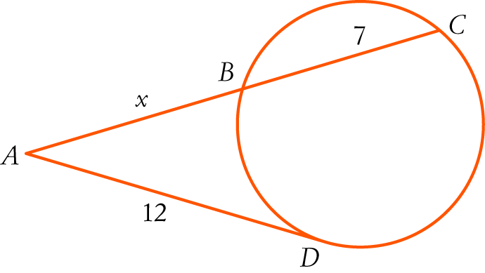

A 5

B 

C 9

D 16

E 

[1 mark]

2 In the diagram, PR is a diameter. The size of ∠PRQ is:

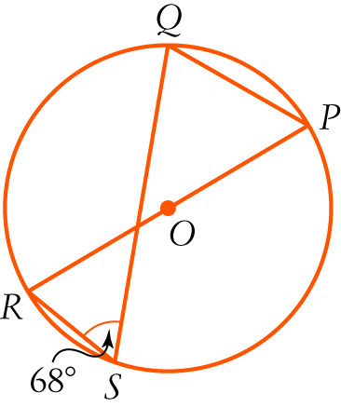

A 68°

B 34°

C 102°

D 90°

E 22°

[1 mark]

3 How many different committees of 3 people can be chosen from a group of 15?

A 2730

B 45

C 455

D 105

E 120

[1 mark]

4 There are 46 friends and relatives at Bob and Carol’s engagement party, not including Bob and Carol. Twenty of the guests are friends of Bob and 18 are friends of Carol. Twelve guests are friends of both Bob and Carol. How many people at the party are relatives (but not friends) of Bob or Carol?

A 8

B 26

C 34

D 28

E 20

[1 mark]

5 Counting 1 at the top as row 0, what is the fourth number on row 8 of Pascal’s triangle?

A 42

B 35

C 56

D 21

E 28

[1 mark]

Part B

7 short answer questions

25 marks

Show your working where appropriate.

6 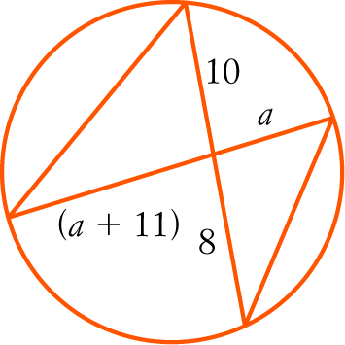

Find the value of a giving reasons.

[4 marks]

7 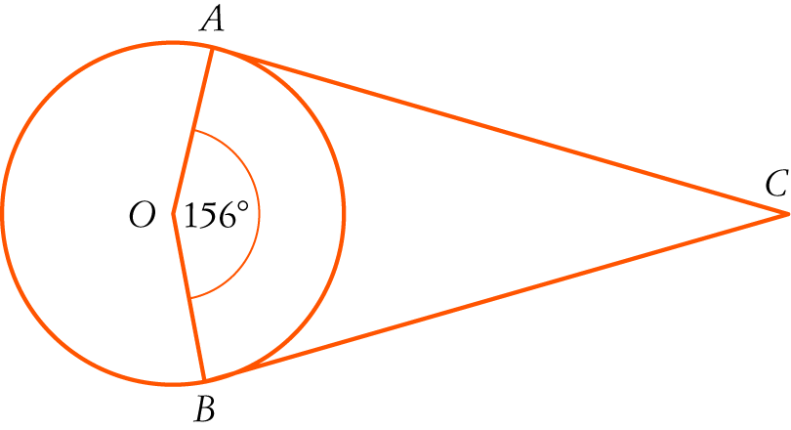

In the diagram, AC and BC are tangents and O is the centre of the circle.   
Find the size of ∠ACB, giving reasons.

[3 marks]

8 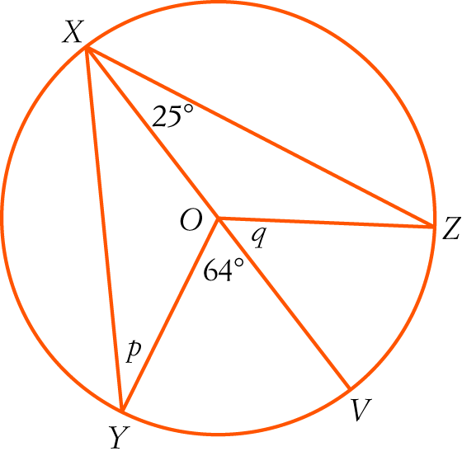

In the diagram, XV is a diameter.

a Find the value of q giving reasons.

b Find the value of p giving reasons.

[4 marks]

9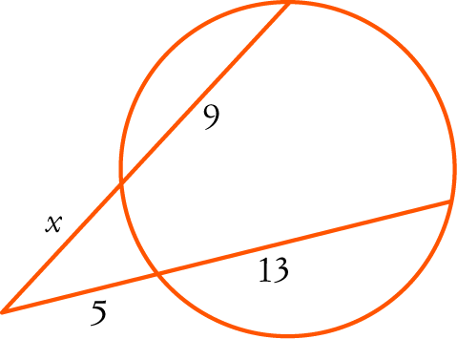

Find the value of x in the diagram. Give reasons.

[3 marks]

10 Show that  (i.e. 15C6 = 14C6 + 14C5).

[Note: this should be a 2 mark question as it is a specific case not a general proof.]

[5 marks]

11 In a particular class, no-one does both Physics and Art, but there are 4 people who do Art and Music and 2 people who do Physics and Music. Altogether there are 6 people who do Physics, 10 who do Art and 7 who do Music. There are 25 people in the class. How many do none of Physics, Art or Music?

[3 marks]

12 A mixed volleyball team of 3 men and 3 women is selected from 6 men and 7 women.   
How many different teams are possible?

[3 marks]

Test continued over page

Part C

3 analysis questions

20 marks

Show your working where appropriate.

13 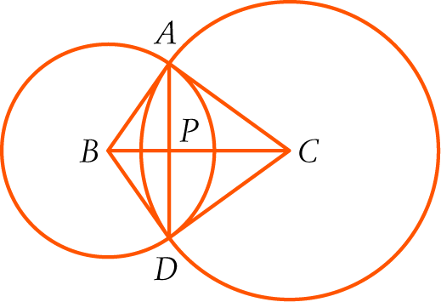

In the diagram, B and C are centres of the circles. The circles intersect at A and D.   
BC and AD intersect at P.

a Prove that Δ BAC ≡ Δ BDC.

b Explain why BC ⊥ AD.

c Given BA is a tangent to the larger circle. Prove that ABDC is a cyclic quadrilateral.

[3,2,4: 9 marks]

14 Each question on a multiple choice test has 4 answers, only one of which is correct. After David has answered all the questions he knows or has some idea about, there five left that he has no idea about. What is the probability of him correctly guessing at least 2 of the 5 correctly?

[6 marks]

15 **For n odd**, show that the third number of row n of Pascal’s triangle is divisible by n.

[5 marks]

Total marks: 50

End of test